REV | Description | Date | Substation Design Engineering | Substation Design Engineering | Civil Engineering | Capital Projects  Engineering
0 | Initial Issue | 06/30/2026 | Created by  Alex M. Pina | Reviewed by Patrick J. Fitzgerald
Hyde Park Battery Energy Storage Project

CONFIDENTIAL / CEII (IF APPLICABLE)
DO NOT DISTRIBUTE OUTSIDE AUTHORIZED RECIPIENTS

Eversource Energy
Hyde Park Battery Energy Storage Project

- Introduction
Eversource Energy System Planning has initiated a project to provide near-term capacity relief for Hyde Park Station #496, which is experiencing rapid load growth from step loads and electrification, where recent peaks have exceeded the substation’s firm (N-1) capacity even after prior load transfers. Because additional load transfers are increasingly undesirable (they reduce transfer flexibility, increase exposure on existing circuits, and consume spare capacity at receiving substations), and the long-term remedy (a new substation) is expected to take many years, the project establishes an interim mitigation plan to prevent overload conditions and maintain reliable service until the permanent solution is in place.

The mitigation is a Battery Energy Storage System (BESS) designed primarily for peak shaving. The BESS site will be located at 401-403 Cummins Highway in Boston Massachusetts in the Hyde Park Neighborhood. The batteries will charge during light-load periods and discharge during peak-load periods to reduce the substation peak demand, with capability to support multi-day peak events. The project also includes ongoing load forecast monitoring and, if needed prior to BESS in-service, coordination of temporary alternatives such as spot generation, voltage reduction, or targeted load shedding during typical peak hours (e.g., early evening) to maintain system reliability.
This scope overview supports Substation Design to integrate the existing 13.8 kV distribution infrastructure with a new Battery Energy Storage System (BESS) facility at the Station 360 site. Station 360 will include 4 standalone interconnection breakers, and the BESS system. The engineering effort is focused on delivering a complete, safe, and reliable interconnection of the Nomad BESS to the Eversource distribution system.
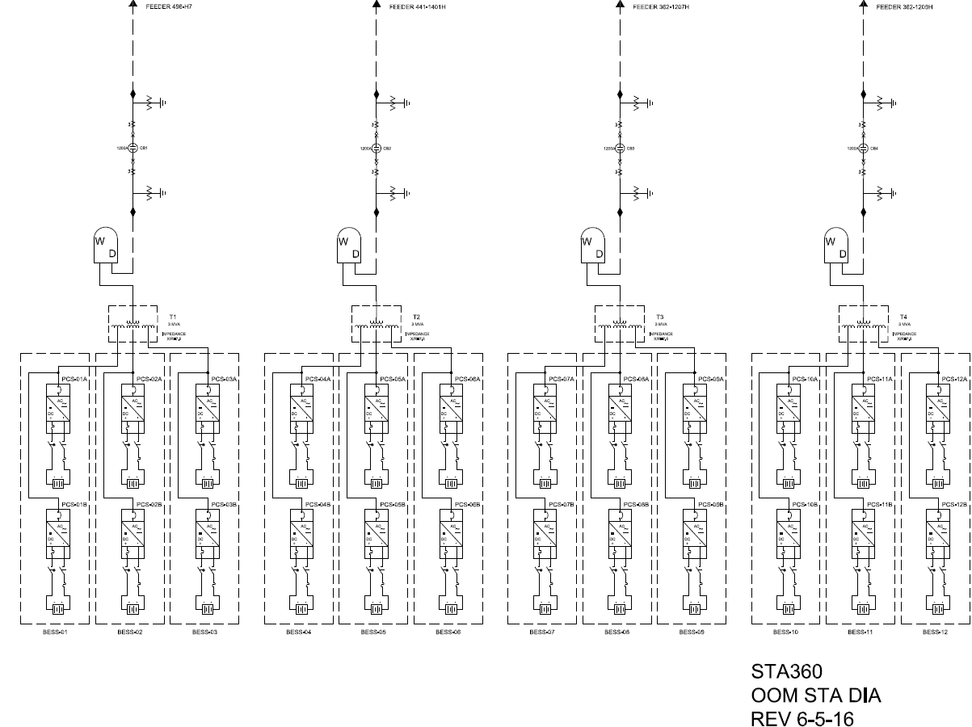
Figure 1 - Proposed BESS Site (Station 360)
- Scope of Work – Major Materials
The following major equipment will be installed for this project:
- Develop a new substation approximately 200’X200’
- Twelve (12) Nomad Voyager Eagle LFP BESS systems
- Four (4) Siemens SDV7 Standalone 1200A breakers with associated:
  - Controls and protections
  - Disconnect Switches
  - Potential Transformers
- Eight (8) Wooden Riser poles for riser structures
  - Four (4) for the Distribution Feeders
  - Four (4) for the connections to the GSUs
- Four (4) 3 MVA, 13.8kV – 480V GSUs
- Two (2) Three phase, 1500KVA, 13.8 KV – 480V Station Service Transformers SSTs
- One (1) Three phase, 125KVA, 480V – 120/208V Dry type SST
- Four (4) Metering Transcolusres
The following conduits and ducts banks are to be installed:
- Twelve (12) Conduits runs from the nomad Batteries to the GSUs
- Four (4) Conduits runs from the GSUs to the Standalone Breakers
- Four (4) Conduits Runs from Station 360 to public ways for feeders connections
- One (1) Conduit Run from Station 360 to public way for Telecommunication
- XXX (X) Manholes to be installed in the access road for the distribution feeders duct bank
- XXX (X) handholes to be installed in the access road for the telecommunication duct bank
The following cables will need to be installed
- 2,000 feet of 4/0, 600V cable for connection to the GSU to the BESS
  - Four cables per phase, 40’per phase
- 2,750 feet of 250 MCM for the connection from the Riser Structure to the GSU
  - One Cable per phase,220’ per phase
- XXX feet of cable for AC Power
The following new structures are to be installed:
- Twelve (12) 251”X108" foundations Pads for the Nomad Batteries
- Four (4) Foundations Pads for the GSUs
- Four (4) Foundations Pads for the Simens SDV7 Standalone breakers
- Three (3) Foundations Pad for the SSTs
The following additional equipment will be required:
- Station Lighting
- 800’ of Perimeter Fence with two (2) vehicle access gates and one (1) Man gate
- Station ground grid
- Control cabinets and control cables
- Scope of Work – Site Preparation
The following site preparation and work will need to be preformed to prepare the existing location for the BESS substation:
- Clear and grub approximately 2.5 acres
- Clear approximately 1.75 acres of wooded area for access road
- 20’ wide, 760’ long new Access Road with curb cut
- Earth work required for Access Road:
  - Cut 2520 CY of material
  - Fill 570 CY
  - Retaining Wall 280 LF, approximately 14’ tall
- 750 CY of trap rock

